**ASSIGNMENT 1**

**Domain**: IoT

**Assignment** on **SMART HOME AUTOMATION IN TINKERCAD**

**Team Members**:

KEERTHIGA M-513119106308

PRAVEEN D-513119106704

KALAIMANI P- 513119106035

AJAYPRABU R-513119106706

**CIRCUIT:**

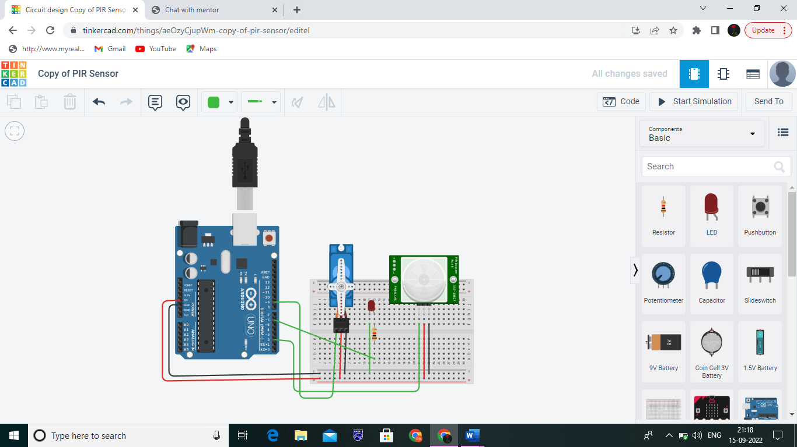

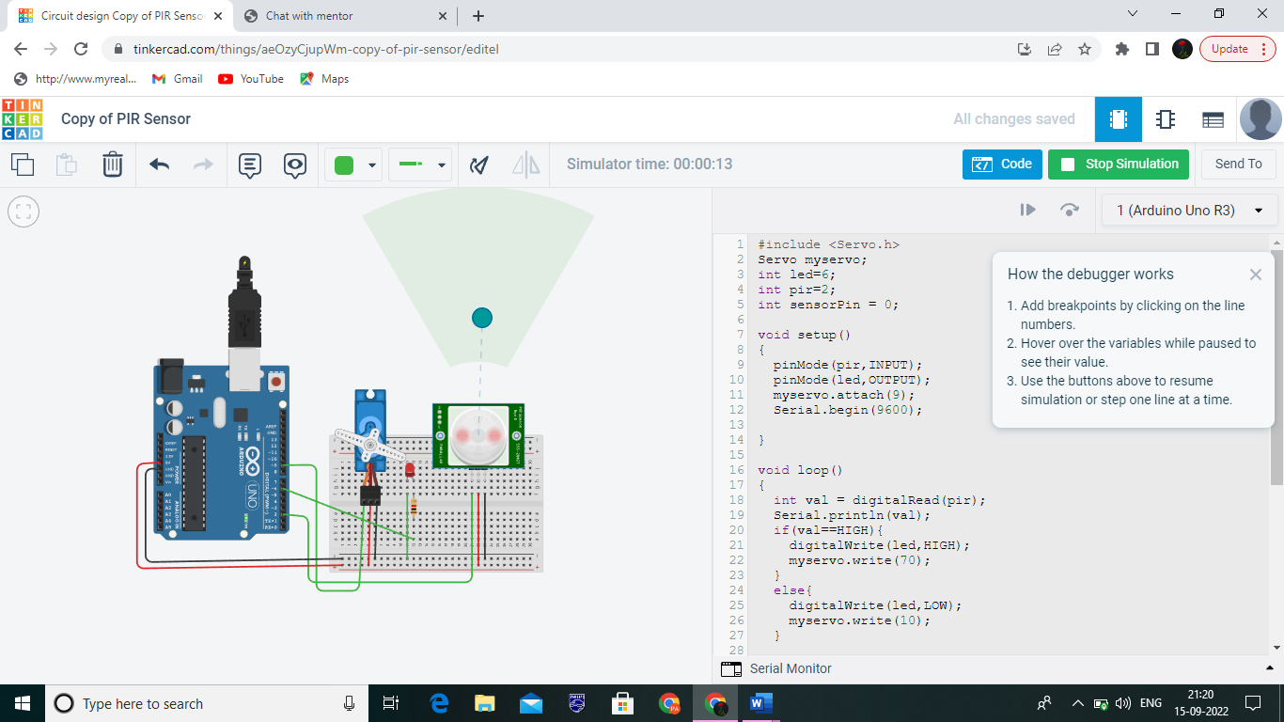

**COMPONENTS USED:**

PIR1-34.79830677290829, -182.4779542037899, -145.23406374501988, -63.98113091291614 PIR Sensor- 1 quantity

U1-Arduino Uno R3- 1 quantity

SERVO1- Positional Micro Servo- 1 quantity

D1- Red LED- 1 quantity

R1- 1 kΩ Resistor-1 quantity

**CODE:**

#include <Servo.h>

Servo myservo;

int led=6;

int pir=2;

int sensorPin = 0;

void setup()

{

pinMode(pir,INPUT);

pinMode(led,OUTPUT);

myservo.attach(9);

Serial.begin(9600);

}

void loop()

{

int val = digitalRead(pir);

Serial.println(val);

if(val==HIGH){

digitalWrite(led,HIGH);

myservo.write(70);

}

else{

digitalWrite(led,LOW);

myservo.write(10);

}

delay(10);

int reading = analogRead(sensorPin);

//measure the 5v with a meter for an accurate value

//In particular if your Arduino is USB powered

float voltage = reading * 4.68;

voltage /= 1024.0;

//now print out the temperature

float temperatureC = (voltage-0.5)*100;

Serial.print(temperatureC);

Serial.print("degrees C");

delay(1000);

}

**TINKERCAD LINK:**

https://www.tinkercad.com/things/aeOzyCjupWm-copy-of-pir-sensor/editel